SALT LAKE CITY POLICE DEPARTMENT
Mike Brown Police Chief

PUBLIC INFORMATION | May 15, 2019

FOR IMMEDIATE RELEASE
39th Annual SLCPD Fallen Officer
Memorial Service
Officers, civilians, Explorers, and families recognize and honor
our SLCPD Fallen Office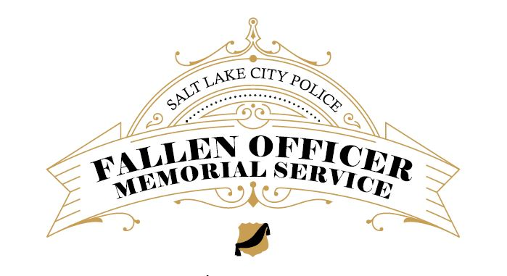

SALT LAKE CITY — In honor of Police Week, the Salt Lake City Police Department will pay tribute to its fallen officers at a memorial service next Thursday afternoon.

Fallen Officer Memorial – Memorial Service
When: Thursday, May 16, 2019, 3:00 p.m.
Where: Public Safety Bldg. plaza, 475 S. 300 E.
Who: Media and public are invited to attend
Please join SLCPD officers and civilian employees as we gather to remember those who have made the ultimate sacrifice while serving this community.

The Police Department invites the media to attend.

###
MEDIA CONTACT:  Public Relations Unit  801.799.NEWS  801.799.6397 | PUBLIC SAFETY BUILDING:  475 South 300 East  MAILING ADDRESS:  PO Box 145497, SLC UT, 84114-5497 | EMAIL:  slcpdpr@slcgov.com  WEBSITE:  www.slcpd.com

FOLLOW US ON: Twitter | YouTube | Facebook | Nextdoor

