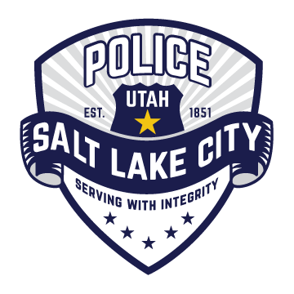
Police Chief Mike Brown

Salt Lake City Police Department

Chief Mike Brown has served in the Salt Lake City Police Department since 1991. He was appointed Chief of Police on May 3, 2016, and prior to that was the Interim Police Chief from June 11, 2015. He has held many positions throughout the department during his 28-year career, and most recently was the Commander for the Special Operations Bureau. As the Interim Police Chief, he implemented a Civilian Advisory Board (CAB)
in 2015.
Chief Brown completed the FBI’s National Executives Institute and the Major Cities Chiefs Association’s Police Executive Leadership Institute. Chief Brown is the Second Vice President of MCCA has been an active member of the MCCA Intelligence Commanders Group and Drug Commanders Group and currently serves on the MCCA Forensic Science Committee. He was recently selected to serve on the National Law Enforcement Exploring Committee. Chief Brown holds a B.S. in General Studies from Columbia College.
Chief Brown’s experience has been focused on a number of specialty functions to address community needs, participation and management of special events and demonstrations, serious collision investigations, and coordination with federal and municipal agencies. As the Special Operations Bureau commander, he oversaw SWAT, Safe Streets Gang FBI Task Force, DEA Metropolitan Narcotic Task Force, Organized Crime Unit, Hazardous Device Unit, Motorcycle Squad, Public Order Unit and Accident Investigation.

